Contents
1 Introduction 4
1.1 Purpose and Scope 4
1.2 BAFL Backup in Context 4
1.2.1 Client Application Uses 4
1.2.2 Backup Application Uses 4
1.3 UML Diagrams 4
2 Backup System 5
2.1 Binaries 5
2.2 Purpose of Backup Server 5
2.3 Types of Backup Server 5
3 BAFL Client DLL Implementation 6
3.1 Class Diagram 6
3.2 Public API 7
3.2.1 CBaBackupSessionWrapper 7
3.2.1.1 Known Issues in CBaBackupSessionWrapper 8
3.2.2 MBackupObserver 8
3.2.3 MBackupOperationObsever 8
3.3 Private Classes 9
3.3.1 RBaBackupSession 9
3.3.2 CBaLockChangeNotifier 9
3.3.2.1 Register File Sequence Diagram 10
3.3.3 CBaBackupOperationNotifier 11
3.3.3.1 Register Backup Start / Stop Sequence Diagram 11
4 Base Backup Server Implementation 12
4.1 Class Diagram 12
4.2 Use Case: Close All File Processing 14
4.2.1 New Design 14
4.2.1.1 A note on CloseAll and NotifyBackupOperationL 14
4.2.1.2 Counter 14
4.2.1.3 A Note on Session Closing 14
4.2.2 Introduced API 14
4.2.3 Timers 15
4.2.3.1 Common Code 15
4.2.3.2 CloseAll Returning 15
4.2.4 Patchable Constants Used in This Sequence 16
4.3 Base Backup Server Sequence Diagrams 17
4.3.1 Backup Operation Notifications 17
4.3.2 Base CloseAll Sequence Diagrams 18
4.3.2.1 No timeout 18
4.3.2.2 ReRegistrationTimer Times Out 19
4.3.2.3 BackupOperationTimer Times Out 20
5 UIKON Backup Server 21
5.1 Class Diagram 21
5.2 UIKON Backup Server Sequence Diagrams 22
5.2.1 No Timeout 22
5.2.2 ReRegistrationTimer Times Out 23
6 Patchable Constants 24
7 Testing 25
7.1 Full Backup Suit Testing 25
7.2 Details of t_backupsrv 26
7.2.1 Class Diagram 26
7.2.2 Notes on t_backupsrv 27
7.2.2.1 Threading 27
7.2.2.2 Tests 27
7.2.2.3 State Machine Thread and Active Object Local Variables 27
7.2.2.4 Startup, Thread and Observer Creation 28
7.2.2.5 CloseAll tests 28
7.2.2.6 Delayed Observer Response 29
7.2.2.7 Session Dropping 29
7.2.2.8 Single File Tests 29
7.2.2.9 Cleanup 29
8 Further Information 30
8.1 People 30
8.2 References 30
8.3 Open Issues 30
8.4 Glossary 30
8.5 Document History 30

Introduction

Purpose and Scope
This document describes backup functionality contained in System Libraries BAFL component and UI Frameworks UIKON component.
Target audience of this document are:
- Technology architects – to understand the architecture of the backup components.
- Software Engineers – to aid in future backup-related work in these components.
- Defect fixers – to get background information about the implementation of backup.
- Verification Engineers – to design any future tests for backup APIs.

BAFL Backup in Context
The BAFL client DLL and server are used as part of the integrated Backup and Restore architecture that backs up and restores data from a Symbian OS devices onto a PC. This data could include information such as contacts, emails and anything any installed application wishes to register to be backed up.

Client Application Uses
Any client application can register with the BAFL client DLL to be notified when a backup starts/ends or when files owned by the application should be closed/re-opened should it employ backup/restore for its own data files.

Backup Application Uses
In Symbian OS the backup process is performed on request by the Secure Backup Engine (SBE) which is owned by the Connectivity technology stream. It is this backup engine the controls the backup/restore operations communicating with the BAFL backup server to trigger notification events to be sent to the backup server’s clients. The backup server notifies clients when a backup is about to start /stop and to release/retake file locks of the files registered.

UML Diagrams
For full UML diagrams see Enterprise Architect diagrams in Perforce. See References in section 8.2 on page 31.

Backup System

Binaries
The BAFL backup client code and public APIs are part of bafl.dll. The BAFL backup sever is located in baksrv.dll. The UIKON backup server is located in eikbackupsrv.dll.
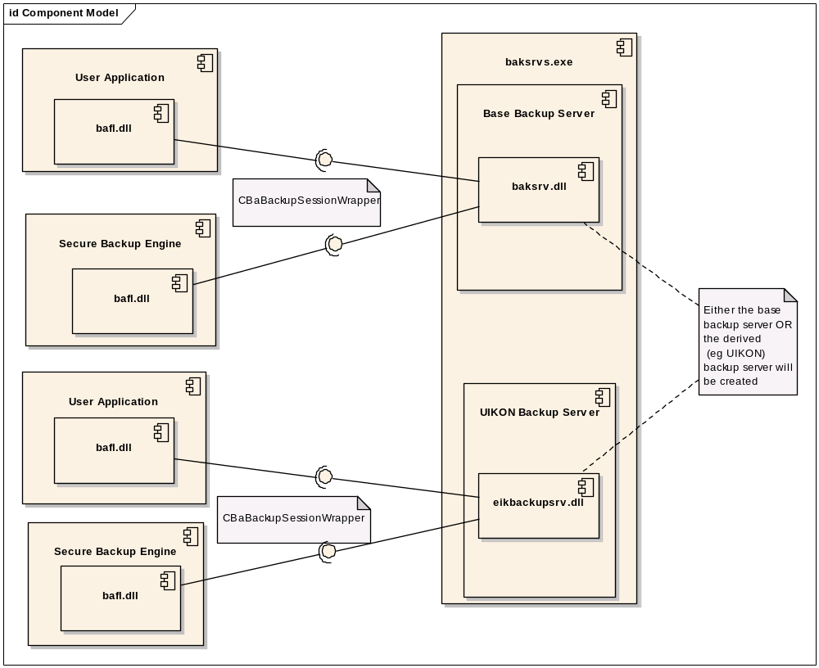

Purpose of Backup Server
The BAFL backup server provides client code with a number of services associated with performing phone to PC data backups.

Types of Backup Server
There are two different ways of using the BAFL backup server (CBaBackupServer). It can be instantiated and used by itself (“base server”) or it can be derived from to create a derived backup server. For example the UIKON component derives from CBaBackupServer to create CEikServBackupServer.

BAFL Client DLL Implementation

Class Diagram
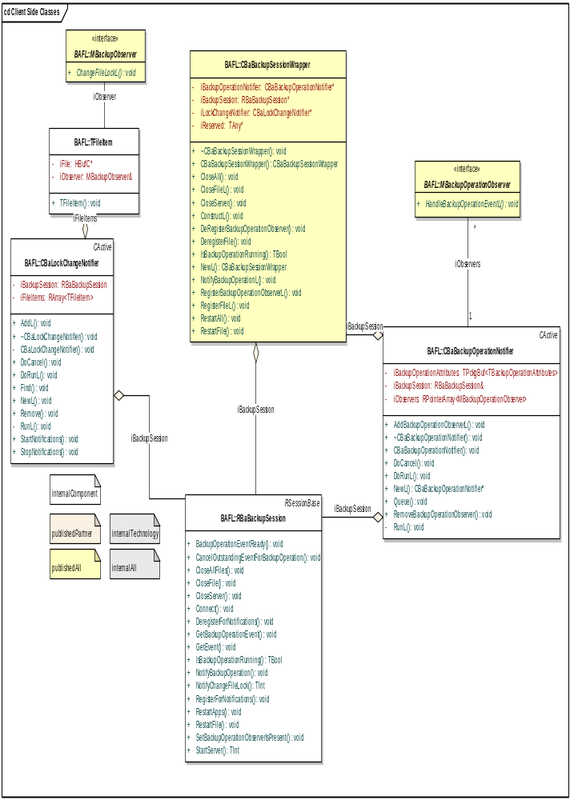

Public API
These classes are all @publishedAll and @released.

CBaBackupSessionWrapper
This client DLL can be used to register for notifications regarding backups as well as trigger the raising of these notifications.
Method Name | Implementation | User
RegisterFileL | Used to register a file for lock change notification. Creates an instance of CBaLockChangeNotifier if one doesn’t already exist and calls CBaLockChangeNotifier::AddL. User code must pass in an instance of a subclass of mixin interface MBackupObserver and the name of the specific file. | End user application
DeregisterFile | Used to deregister a file for lock change notification. Calls CBaLockChangeNotifier::Remove. | End user application
RegisterBackupOperationObserverL | User must pass in an instance of a subclass of mixin interface MBackupOperationObserver. This instance receives a callback when a backup starts or ends. | End user application
DeRegisterBackupOperationObserver | Removes a previously stored backup operation observer from the list. | End user application
IsBackupOperationRunning | Returns ETrue if a backup is underway. | End user application
CloseFile | Same as CloseAll but for one file only. | Symbian backup system
RestartFIle | Same as RestartAll but for one file only. | Symbian backup system
CloseAll | Causes all registered file observers to be notified with the passed in lock status. | Symbian backup system
RestartAll | Causes all registered file observers to be notified that files can be re-opened. | Symbian backup system
NotifyBackupOperationL | Starts and stops a backup. | Symbian backup system

Known Issues in CBaBackupSessionWrapper
Defects have been raised to cover the following issues:
- It is possible for RegisterFileL to be used to add a file lock registration while a backup is in progress.
- It is also possible for CloseAll to be called more than once while a backup is in progress. This could lead to a situation where two sets of notifications are being raised at the same time and, in the case of the UIKON backup server, two sets of potentially conflicting system messages being sent to applications.

MBackupObserver
This interface class is used to receive notifications when a previously registered file needs to have its lock status changed. A derived class from this interface must be supplied to RegisterFileL. Only one method is inherited:

Method Name | Implementation
ChangeFileLockL | Notifies client code that a file lock must be changed. This implementation must complete synchronously.

MBackupOperationObsever
This interface class is used to receive notifications when a backup is started or finishes. A derived class from this interface must be supplied to RegisterBackupOperationObserverL. Only one method is inherited:
Method Name | Implementation
HandleBackupOperationEventL | Notifies client code that a file backup has begun or finished.

Private Classes

RBaBackupSession
Client / server interface to the BAFL Backup Server for CBaBackupSessionWrapper.

CBaLockChangeNotifier
One instance of this Active Object is created per session to handle all the file locks that are registered through that instance of the Wrapper. Contains a sub-class TFileItem which is a mapping between a specific file and a specific observer instance (derived from MBackupObserver).
When a file is first registered in the backup server via the client DLL using CBaBackupSessionWrapper::RegisterFileL a call is made to CBaLockChangeNotifer::AddL this in turn calls CBaLockChangeNotifier::StartNotifications which calls RBaBackupSession::RegisterForNotifications with the iStatus of this class. It is this which is completed later by the sever to return the file lock notifications to the client. Following the call to CBaLockChangeNotifier::StartNotifications a call is made into the server using the synchronous method RBaBackupSession::NotifyChangeFileLock to register this particular file for notifications from the server.
When the file is registered in the server the count of total registered files (iRegisteredFilesCount in CBaBackupServer) is incremented by a call to CBaBackupServer::IncrementRegisteredFilesCount.
Subequent calls to CBaBackupSessionWrapper::RegisterFileL use the existing instance of CBaLockChangeNotifier for that session.
When this message is completed CBaLockChangeNotifer::DoRunL makes a synchronous call to RBackBackupSession::GetEvent to discover which file needs updating and to what lock status. It then loops through the array of TFileItems to see which observer objects need to be notified. MBackupObserver::ChangeFileLockL is called synchronously on all such observer classes found. Next CBaLockChangeNotifer::DoRunL calls CBaLockChangeNotifer::StartNotifications to re-register with the server for further notifications.
The new design relies on the call to MBackupObserver::ChangeFileLockL being synchronous as when notification re-registration occurs in the server it is known that the client code has finished processing the file lock change notification for all observers interested in that file for that session.

Register File Sequence Diagram
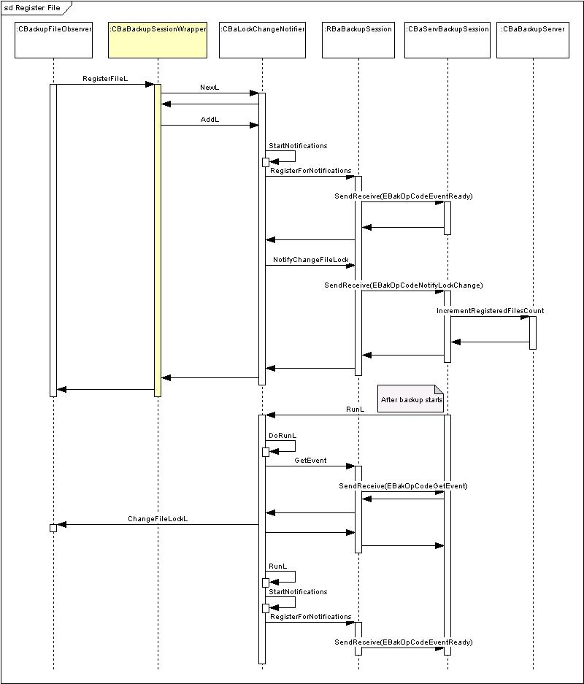

CBaBackupOperationNotifier
One instance of this Active Object is created per session to handle all observer class instances that need to be notified when a backup starts or ends.
When an observer is first registered with CBaBackupSessionWrapper::RegisterBackupOperationObserverL CBaBackupOperationNotifier::AddBackupOperationObserverL is called. This in turn calls CBaBackupOperationNotifier::Queue which calls RBaBackupSession:: BackupOperationEventReady with the iStatus of this class. It is this which is completed later by the sever to return the observer notifications to the client.
When the message is completed CBaBackupOperationNotifier::DoRunL loops through all the backup observers that have registered in this session and notifies them by calling MBackupOperationObserver::HandleBackupOperationObserver.

Register Backup Start / Stop Sequence Diagram
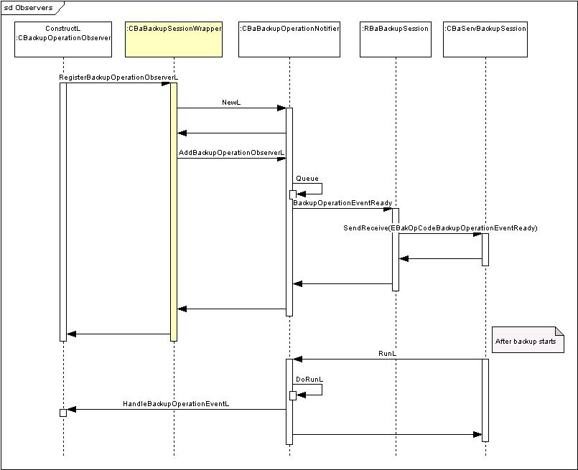

Base Backup Server Implementation

Class Diagram
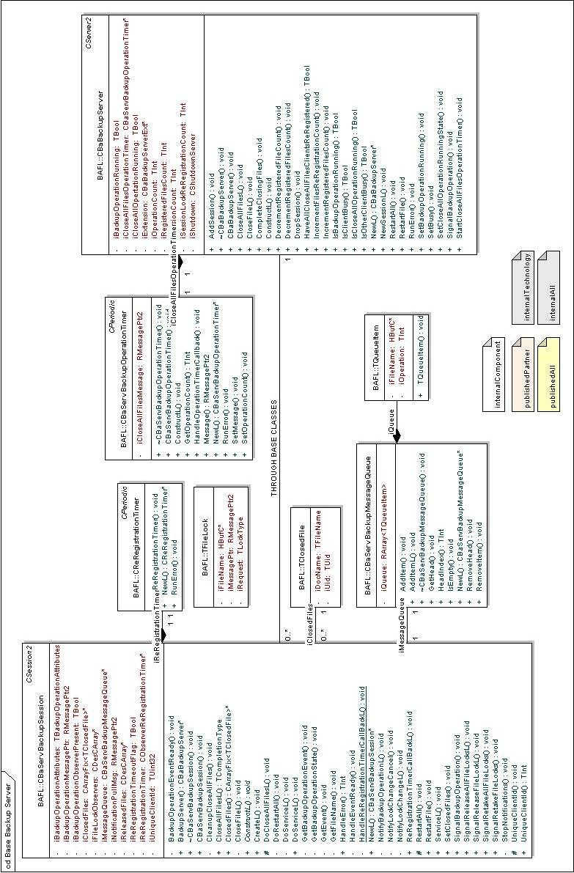

Use Case: Close All File Processing
The OS Library documentation for the BAFL backup functionality states that client applications are able to call the public API CBaBackupSessionWrapper::CloseAll and then use thread blocking or an Active Object to wait for that call to complete. The completion of the call indicates to the client that the backup process can begin.
Prior to calling CBaBackupSessionWrapper::CloseAll multiple clients can register to be notified about multiple files whose lock status must be changed before a backup can be started.
In a previous implementation due to race condition issues completion of the asynchronous call may occur before some of the client applications with registered files have finished processing their lock notifications.
This could occur because, in the example the UIKON backup server, the raising of file lock notifications is asynchronous and happens independently of the closing of window-based, i.e. non-server, applications. Once all window-base applications are closed CBaBackupSessionWrapper::CloseAll completes regardless of the status of the file lock processing.

New Design

A note on CloseAll and NotifyBackupOperationL
It should be noted that in the new design CBaBackupSessionWrapper::CloseAll functionality is completely decoupled from backup notification functionality accessed via CBaBackupSessionWrapper::NotifyBackupOperationL and CBaBackupSessionWrapper::IsBackupOperationRunning. Technically CBaBackupSessionWrapper::CloseAll, CBaBackupSessionWrapper::CloseFile, etc can be called without first indicating that a backup is occurring by calling CBaBackupSessionWrapper::NotifyBackupOperationL. This is not advised.
When a call to CloseAll is made a Boolean flag called iCloseAllOperationRunning is set to ETrue in CBaBackupServer.

Counter
The current design has solved this problem, both in the UIKON backup server and the Base Backup Server types, by introducing a new counter in CBaBackupServer called iRegisteredFilesCount. Every time a new file is registered for file lock change notifications this counter is increased. If a file is de-registered the counter is decreased. If a session drops the counter will be decreased by the number of files that session had registered as held in iFileLockObservers.
When a CloseAll is started by a call to CBaBackupSessionWrapper::CloseAll a second counter in CBaBackupServer called iSessionLockReRegistrationCount is set to zero. This counter is incremented every time a client application re-registers for file lock notification having processed the notification they have previously received as a result of the start of the current backup.
This re-registration happens automatically in the BAFL client-side DLL so no client application code needs to be aware of the mechanism.

A Note on Session Closing
Should a session close unexpectedly, for example due to the client code containing the session crashing, the server-side session will automatically be closed and removed. This will, in turn, remove decrement the server-side count for each of these previous registrations made by that specific session. This is possible because CBaServBackupSession::~CBaServBackupSession has been adapted to call CBaBackupServer::DecrementRegisteredFilesCount with the count of members of its iFileLockObservers array.

Introduced API
The new design resulted in two new published APIs (@Internal All) : CBaBackupServer::HaveAllCloseAllFilesClientsReRegistered
CBaBackupServer::SetCloseAllOperationRunningState

Timers
A number of timers are important in the CloseAll functionality.
- One instance of CReRegistrationTimer is created per CBaServBackupSession. This class is used by both the UIKON and base server. The timer is triggered iwhen a file lock notification is raised to the client DLL in CBaServBackSession::SignalReleaseFileLock but only if a call to CBackupServer::IsCloseOperationRunning returns ETrue. If the DLL re-registers for notifications before the timer expires there is no effect. The timer expires if the end-client user code has taken too long to process its file lock notification. At this point iSessionLockReRegistrationCount is incremented. This timer has been introduced so that the backup process cannot hang if, for example, a piece of client code becomes stuck in an infinite loop while attempting to process its file lock changes. A flag in CBaServBackupSession, iReRegistrationTimeoutFlag, is used to ensure that if, following the timeout period, the client application re-registers for notifications then iSessionLockReRegistrationCount is not incremented twice.
- CBaServBackupOperationTimer is only used in the base server and there is only ever exactly one instance. It is started by a call to CloseAll in the Base Backup Server and stores an RMessagePtr2 of the CloseAll message. It loops a maximum of three times. On each iteration it calls CBaBackupServer::HaveAllCloseAllFilesClientsReRegistered to see if all file lock change clients have re-registered – if they have it completes the RMessagePtr2 with KErrNone. If the timer loop has executed 3 times it completes the message with KErrLocked.
- In either case it calls CBaBackupServer::SetCloseAllOpertionRunningState to set the value to EFalse.
- The value of 3 times the CBaServBackupOperationTimer interval must be longer than the CReRegistrationTimer interval in case of the worst case scenario where at least one file lock notification re-registration times out.
- The UIKON backup server is not only responsible for making sure that all file lock notifications are raised but also that all window-based (ie non-server) applications are closed before a backup is started. The equivalent of CBaServBackupOperationTimer in the UIKON server is CShutterTimer. This loops up to 3 times each time checking to whether all non-window applications are closed and that all file locks have been processed (checked via a call to CBaBackupServer::HaveAllCloseAllFilesClientsReRegistered. As in the base server it calls CBaBackupServer::SetCloseAllOpertionRunningState to set the value to EFalse.

Common Code
Both backup server implementations call the common function CBaServBackupSession::DoCloseAllFilesL as part of their CloseAll execution path. This function is responsible for raising the file lock related notifications to the registered user applications.
In the base backup server this is called from CBaServBackupSession::CloseAllFilesL just before the operation timer is started.
In the UIKON backup server it is called from CEikServBackupSession::CloseAllFilesL just before the application shutter class (which in turn starts CShutterTimer) is created.

CloseAll Returning
In the base backup server the asynchronous call to CBaBackupSessionWrapper::CloseAll is completed in CBaBackupServer::HandlePollingTimerCallBackL when either the call to CBaBackupServer::HaveAllCloseAllFilesClientsReRegistered shows all file locks have been completed or when the timer has expired 3 times.
In the UIKON backup server the asynchronous call to CloseAll is made in the window-based application closing code CAppShutter::CheckCompleteL. This uses the new API and ensure that all file locks have been processed before completing

Patchable Constants Used in This Sequence
See Patchable Constants on page 25.

Base Backup Server Sequence Diagrams

Backup Operation Notifications
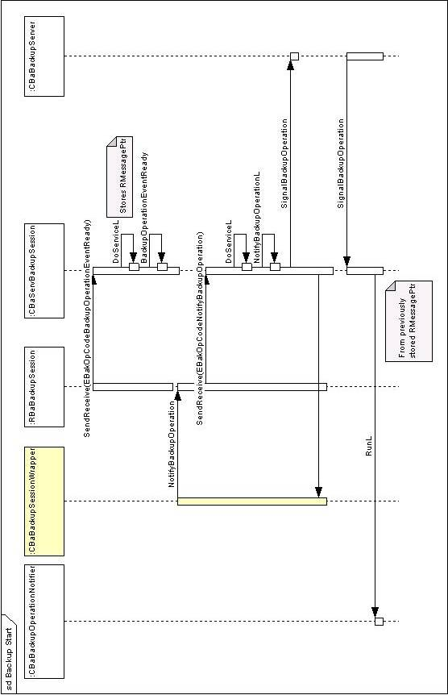

Base CloseAll Sequence Diagrams

No timeout
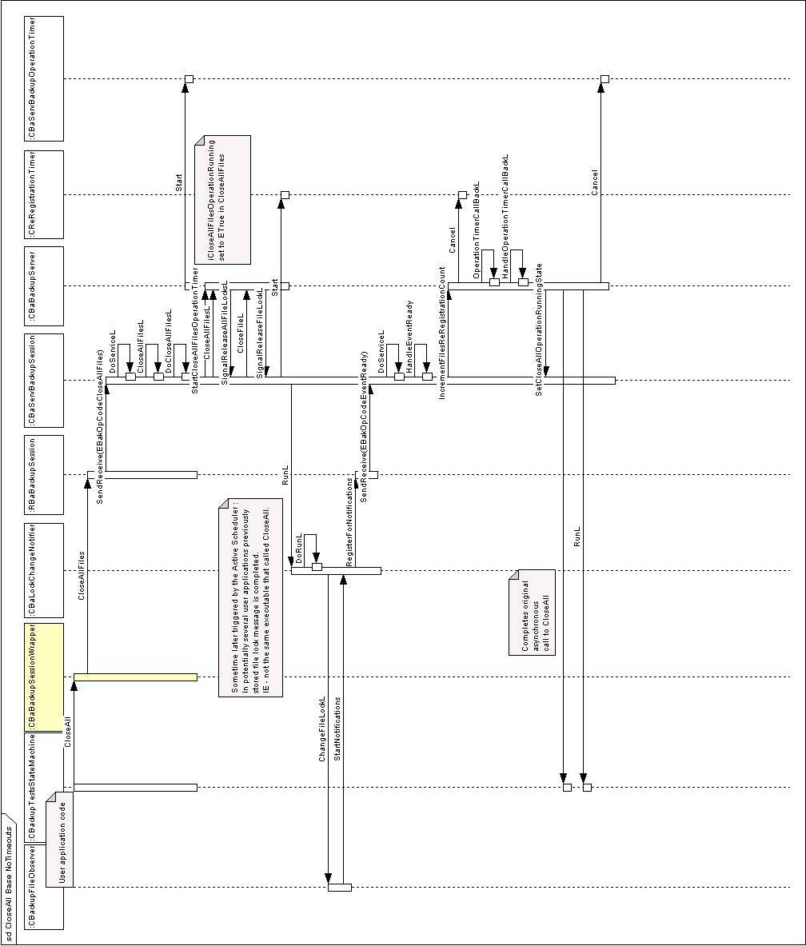

ReRegistrationTimer Times Out
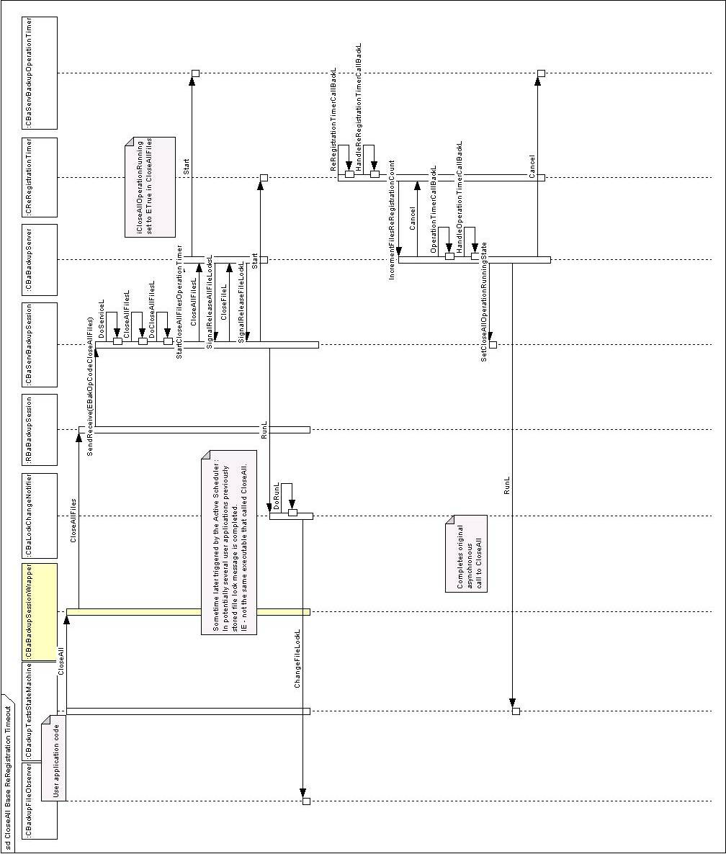

BackupOperationTimer Times Out
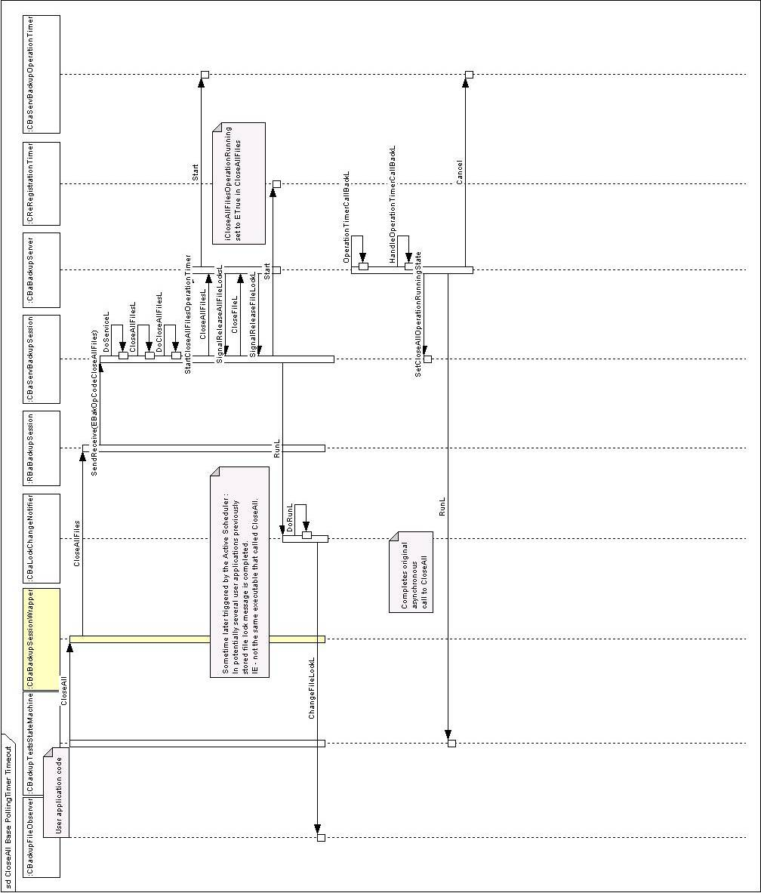

UIKON Backup Server

Class Diagram
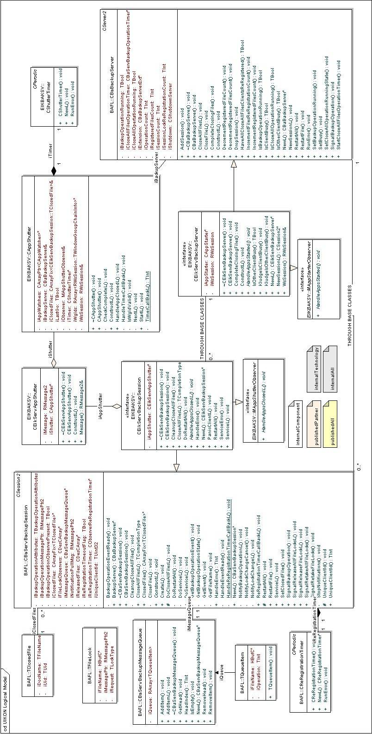

UIKON Backup Server Sequence Diagrams

No Timeout
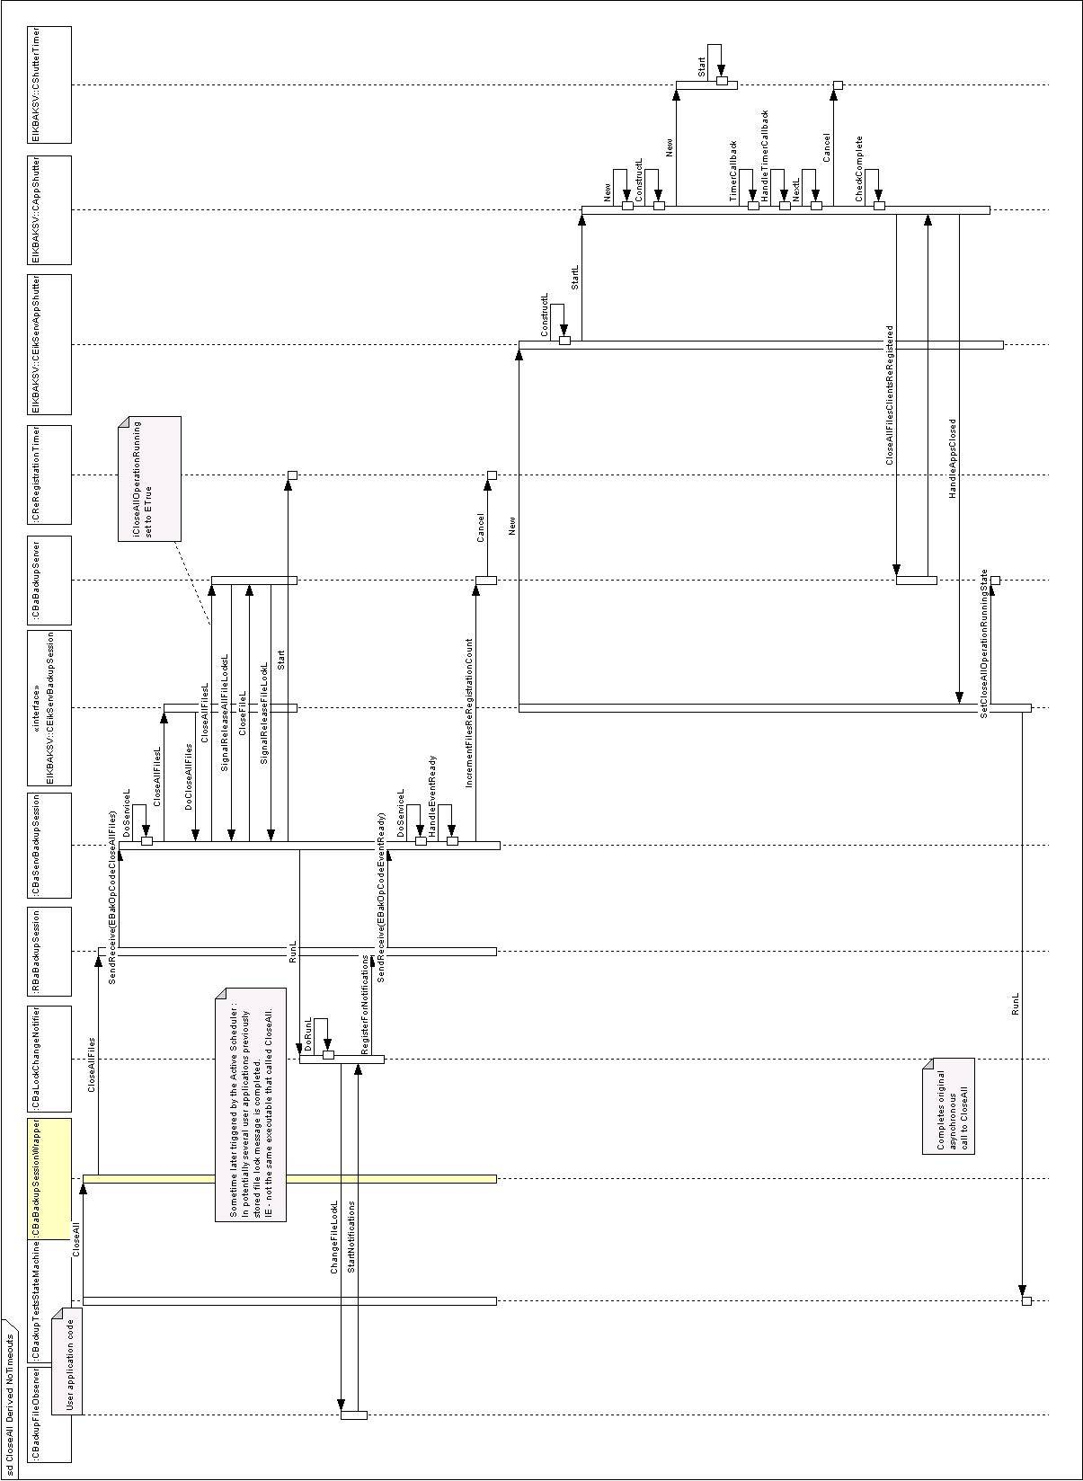

ReRegistrationTimer Times Out
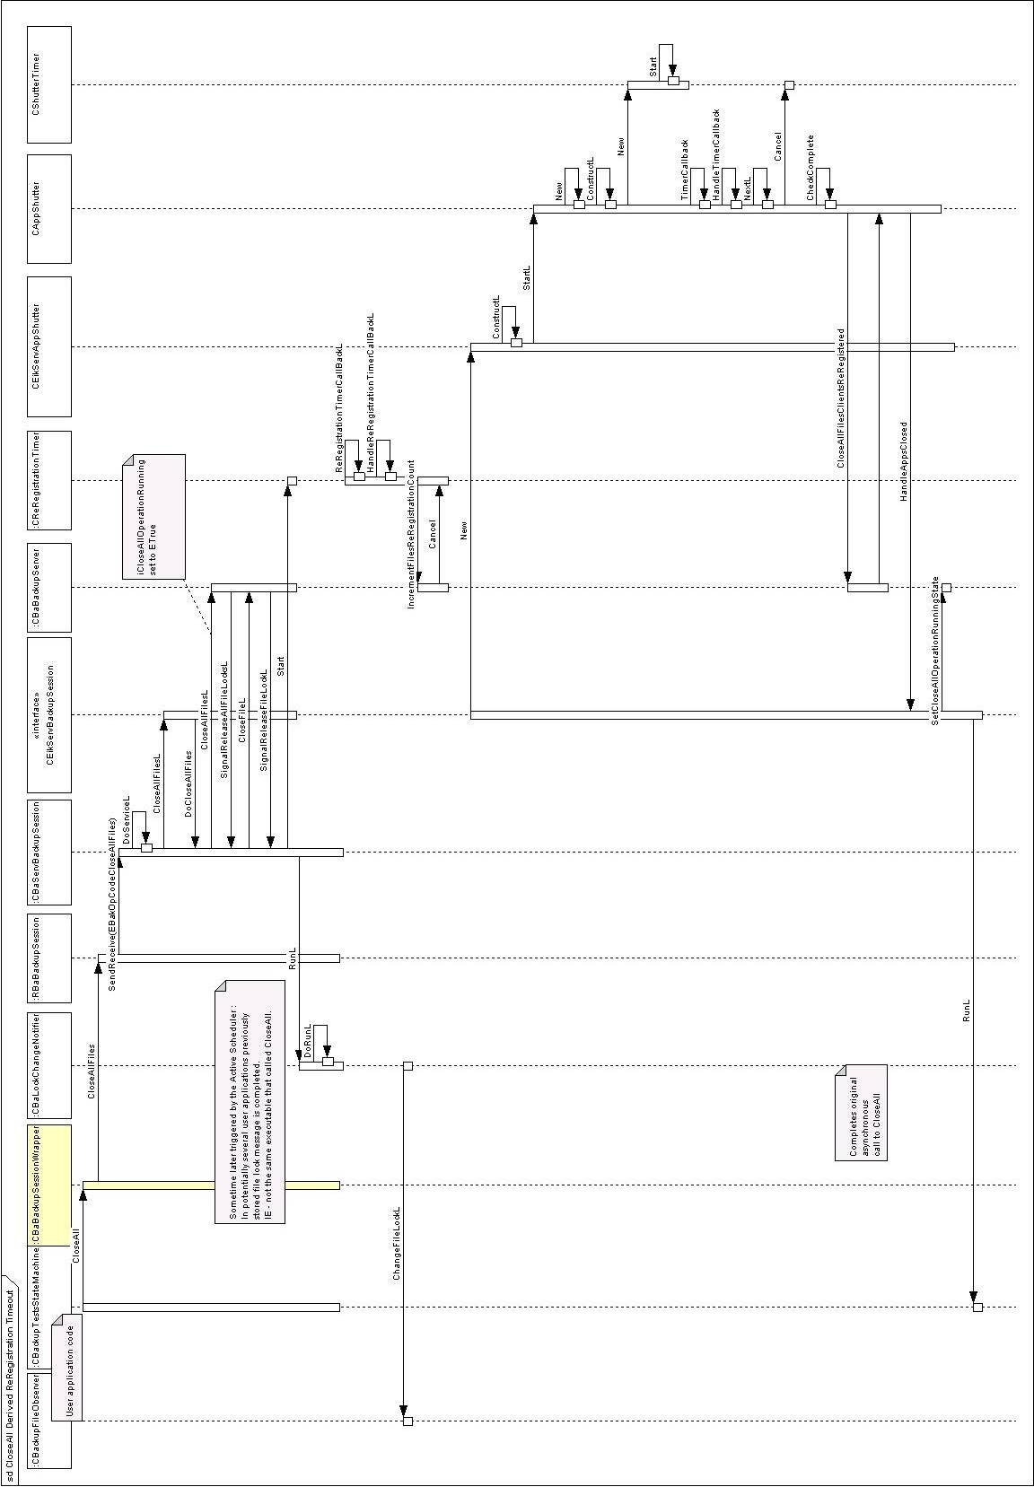

Patchable Constants
Patchable constants are constant values that may be altered by licensees at ROM build time. These values cannot be modified for emulator execution, the default compile time value is used.

Two patchable constants exist in the BAFL backup server:
Constant | Default Value | Usage
KBaBackupFileLockReRegistrationTimeout | 3 seconds | This is defined as amount of time it is expected for a client application to process a file lock notification and re-register for future notifications. If the timer expires a backup may be initiated without all file lock changes having been processed.
KBaBackupCloseallFilesTimeout | 3 seconds | For platforms using the base backup server as provided in BAFL this patchable constant is the timer interval used to check whether all file lock notifications have been processed. If they have or the timer expires 3 times the CloseAll function call will be completed. This variable defines the period of that timer.  The default value is 3 seconds - leading to a default maximum of 9 seconds for file lock changes to be processed in a Base Backup Server.

One patchable constant exists in the UIKON backup server:
Constant | Default Value | Usage
KUIKONBackupCloseAllFilesTimeout | 5 Seconds | If the UIKON backup server is in use and an instance of the client DLL makes a call to CloseAll, a timer will be started to periodically check if all file lock notifications have been processed and all non-server programs have been shut down. If all files and applications are closed or the timer expires 3 times the CloseAll function call will be completed. This variable defines the period of that timer.  The default value is 5 seconds - leading to a default maximum of 15 seconds for file lock changes to be processed and applications to be shut in a UIKON backup server.  The default timer is longer for the UIKON backup server than the base backup server to allow for more time to close window-based applications.

Testing
This section describes the various testing used for base and UIKON backup servers.

Full Backup Suit Testing
Any changes to the client-side DLL, the BAFL backup server or the UIKON backup server must be tested with the following environments:
- BAFL regression unit test suite (bafltests.bat) to ensure any changes have not broken existing tests. These tests should be run on emulator and hardware.
- The changes must be tested with the full Symbian PC Connectivity regression test suite (contacting a member of the Connectivity team is the quickest way to do this).
- The BAFL regression test suite contains the unit test t_backupsrv which specifically tests BAFL backup functionality. It is important the this is specifically run in three environments:
  - Emulator
  - Techview hardware – uses UIKON backup server
  - TShell hardware – uses base backup server

Details of t_backupsrv

Class Diagram
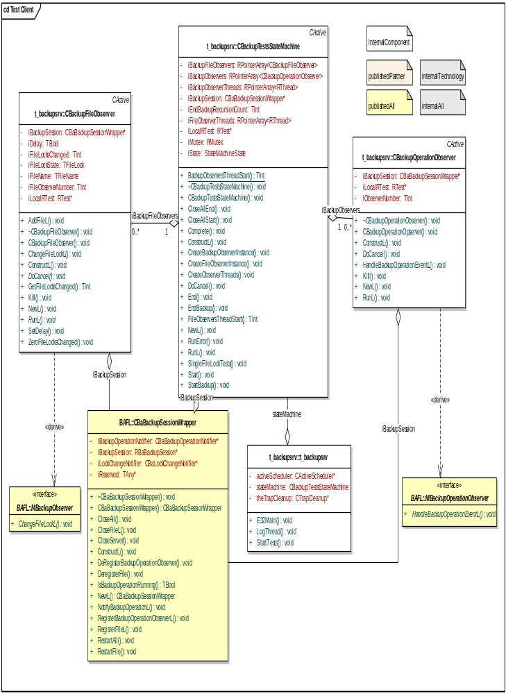

Notes on t_backupsrv

Threading
t_backupsrv operates in a multithreaded environment to simulate several applications waiting for file lock and backup observer notifications. Extra logging has been added (the function LogThread) to help identify which thread execution is occurring in.
Because of stack based data created by objects in the linked-in BAFL client DLL it is crucial that the observer object instances are deleted in the same thread that they are created in. In order to achieve this the observer classes CBackupFileObserver and CBackupOperationObserver have been derived from CActive to turn them into Active Objects. Later RThead::RequestComplete is used to trigger the RunL of that class in the appropriate thread.
RTest does not work across a multi-threaded environment so the state machine and the two observer classed each have their own instance of RTest for the purpose of logging.

Tests
The core of the new t_backupsrv is a state machine (CBackupTestStateMachine) which executes the following tests:
- CloseAll (files to read only)
- CloseAll (file to no access)
- CloseAll (files to read only – one file lock observer delayed by 10 seconds)
- CloseAll (files to no access – one file lock observer delayed by 10 seconds)
- File lock observer session dropped + CloseAll (files to read only)
- Observer session dropped + CloseAll (files to read only)
- Individual file lock tests (using CBaBackupSessionWrapper::CloseFileL and CBaBackupSessionWrapper::RestartFile)
In each case for CloseAll it is checked that the expected number of file lock notifications have been received by the test code before the call to CBaBackupSessionWrapper::CloseAll completes.
In the test for dropping a file lock change notification session and all subsequent tests the expected number of returned file change lock notifications is obviously one less than previously.

State Machine Thread and Active Object Local Variables
Four RArrays in CBackupTestsStateMachine are used to store the thread and Active Object instances for the observer classes (iBackupObserverThreads, iFileObserverThreads, iBackupFileObservers and iBackupObservers).
It is important to note that the CBackupFileObserver and CBackupOperationObserver instances stored in two of these arrays may be accessed by any thread (shared heap) regardless of which thread they are created in and are often accessed by the main thread.

Startup, Thread and Observer Creation
Following E32Main, StartTestsL creates the state machine (CBackupTestsStateMachine) in the main thread. CBackupTestsStateMachine::ConstructL initialises the starting state, adds the state machine to the Active Scheduler and creates the “command” session using CBaBackupSessionWrapper::NewL (this session uses the same API as the observers but is used in the test code for starting stopping backups, sending file lock control commands, etc – hence “command”).
Following the creation of the state machine the main thread then enters the Active Scheduler main loop using CActiveScheduler::Start. Further execution in StartTestsL is then effectively suspended until that Active Scheduler is stopped.
The first state in the state machine is responsible for setting up the observer threads and Active Objects in CBackupTestsStateMachine::CreateObserversThreads. Four of each kind of observer (CBackupOperationObserver and CBackupFileObserver) are created – each in their own thread. An Active Scheduler is created for each of these threads in the static thread start functions BackupObserversThreadStart and FileObserversThreadStart. As with the main thread execution of these functions is effectively suspended at CActiveScheduler::Start until that Active Scheduler is stopped.

CloseAll tests
Six tests of CBaBackupSessionWrapper::CloseAll are performed. Each of these uses common begin and end functions.
CBackupTestsStateMachine::CloseAllStart calls CBackupTestsStateMachine::StartBackup which in turn uses CBaBackupSessionWrapper::NotifyBackupOperationL to inform the backup server that a backup is starting, sets the next state for the state machine and calls CBaBackupSessionWrapper::CloseAll.
The call to CBaBackupSessionWrapper::CloseAll is asynchronous and is completed sometime later in the server. When this happens CBackupTestsStateMachine::RunL is called which goes to the next state in the state machine (previously set by the call to CBackupTestsStateMachine::StartBackup).
The various “return” state machine states call CBackupTestsStateMachine::CloseAllEnd, which uses CBackupTestsStateMachine::EndBackup to check that the expected number of MBackupObserver notifications have arrived, and then move the state machine on to the next state by using CBackupTestsStateMachine::Complete. This completes the iStatus locally causing CBackupTestsStateMachine::RunL to be called.
Nb – the call to CBaBackupSessionWrapper::NotifyBackupOperationL causes four MBackupOperationObserver notifications to be raised (one for each observer instance). These are captured by the CBackupOperationObserver observer instances and logged but currently no checking is undertaken by this test code to ensure that these notifications have been received.

Delayed Observer Response
Two of the CBaBackupSessionWrapper::CloseAll tests require a delay to be introduced for file lock processing in one of the CBackupFileObserver threads. This is required specifically to the new backup server design which ensures that the call to CloseAll is not completed until after all notified file lock observers have re-registered for notifications (or timeout occurs).
This delay is set by a call from CBackupTestsStateMachine::RunL to a specific instance of CBackupFileObserver using CBackupFileObserver::SetDelay. This is done in the main thread. When a file lock change notification is received in CBackupFileObserver::RunL in its own thread a check is made to see if this delay should be inserted.
In the “return” state machine state for these tests following the call to CBaBackupSessionWrapper::CloseAllEnd the delay is reset to off and then a delay of 10 seconds is introduced in the main thread to ensure that the previously introduced delay in the one file lock change observer thread expires before the next test is performed.

Session Dropping
Two of the CBaBackupSessionWrapper::CloseAll tests require a CBaBackupSessionWrapper session to be dropped. This is achieved by calls from CBackupTestsStateMachine::RunL to the Kill functions to the appropriate observer class. The call to Kill takes the RThread that the observer was created in as a parameter.
Kill calls RThread::RequestComplete on the passed in thread. This causes execution to jump to the RunL function of the same object instance but in the thread it was created in. The object can then safely be deleted.
It is worth noting that after the observer Active Object is deleted the Active Scheduler for that thread is stopped. This causes execution to jump back to the line following the call to CActiveScheduler::Start in the appropriate static thread starting function.
Following that execution returns to the main state machine thread in RunL - where Kill was called from. At this point the thread for the deleted observer is deleted.

Single File Tests
Eight files are individually closed and restarted using calls to CBaBackupSessionWrapper:: CloseFileL and CBaBackupSessionWrapper::RestartFile.
CBaBackupSessionWrapper::EndBackup is called synchronously locally to check the all the expected notifications have been received. The second parameter, oneTimeOnly, which has always been set to ETrue for the CloseAll tests is set to EFalse. This means that EndBackup may loop recursively up to 10 times, each with a delay of 0.5 seconds, while waiting for the notifications to arrive.

Cleanup
The final state machine state simply stops the Active Scheduler in the main thread.
This causes execution to jump to directly after where CActiveScheduler::Start is called in StartTestsL. The following line deletes the state machine.
The destructor for the state machine deletes the remaining observer objects, using the appropriate Kill function as outlines above, and then deletes the remaining threads before cancelling the state machine Active Object status.
Following the destruction of the state machine standard application closing is undertaken including a test for memory leaks with __UHEAP_MARKEND.

Further Information

People
Role | Person / People
Reviewers | Stephen Mansfield
Contributors | David Durant, Stephen Mansfield

References
No. | Document Reference | Version | Description
[R1] | //EPOC/master/common/generic/syslibs/bafl/engineering/BAFL Backup Server.EAP | 1.0 | EA diagrams for BAFL backup
[R2] | //EPOC/master/common/generic/syslibs/bafl/docs/BAFL Patchable Constants.doc | 1.0 | Patchable constants for BAFL
[R3] | //epoc/master/common/generic/app-framework/uikon/docs/UIKON Patchable Constants.doc | 1.0 | Patchable constants for UIKON

Open Issues

Glossary
Term | Definition

Document History
Date | Version | Status | Author | Description
dd-mm-yyyy | 1.0 | Issued | David Durant | TBD
12-05-2007 | 0.1 | Draft | David Durant | First draft based on SGL.PPS001.501 Formal Document Template Rev 8.6

